Week 3 Day 2 16/05/2023

# Boolean

* Booleans are the logical values, either true or false. They are the result of logical comparisons.
* Boolean conditionals are often used to decide which sections of code to execute (such as in if statements) or repeat (such as in for loops).

# Truthy and Falsy Values

* Falsy values are not exactly false, but evaluate to false when converted to a Boolean
* Truthy values are not exactly true, but evaluate to true when converted to a Boolean
* All values are truthy unless they are defined as falsy. That is, all values are truthy except false, 0, “”, null, undefined, Not a Number (NaN).

# Boolean basics

* In Boolean logic, a statement can have 2 values, true or false
  + Example 0 – It is raining today.
* Boolean logic evaluates a while statement to see whether it is either true or false.
  + Example 1 – It is raining today AND my feet are getting wet. Both statements are true.
  + Example 2 – It is raining today OR my feet are getting wet. Either statements are true meaning it is true overall.

# Boolean basics continued

As in mathematics, the bit that’s between the brackets () is evaluated first.

BEDMAS (Brackets, Division, Multiplication, Addition, Subtraction)

What is the output of the following?

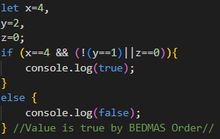

# Exercise 1

* Note down what the following statements will return. Try to figure this out before putting the commands I the console.

# Non-Primitive Data Types

* 1 Object
  1. Used for denoting complex data structure with a collection of properties and methods
* 1a) Array (a type of Object)
  1. A data structure whereby you can store a collection of elements.

All JavaScript values, except primitives, are objects.

# Objects

* Objects are an unordered collection of key/ value pairs, where the
  + Keys are usually strings
  + Values can be any type, even other objects.

Objects are defined by the list of key: value pairs, comma-separated and enclosed by curly braces.

* The person object has 2 properties firstName and lastName with the corresponding values ‘John’ and ‘Doe’.
* When an object has multiple properties, you use a comma (,) to separate them like the above example.

**Note:** Spaces and line breaks are not important. An object definition can span multiple lines.

# Description of Doggy.

* Has name (Fido)
* Have weight
* Mixed Breed
* It’s a dog
* Likes to walk, fetching balls.

## Has properties

* name: fido
* weight: 40
* breed: Mixed
* loves: walks, fetching balls.

# Exercise 2

1. Create a *cat* object containing a first name and last name property, where the values are strings.

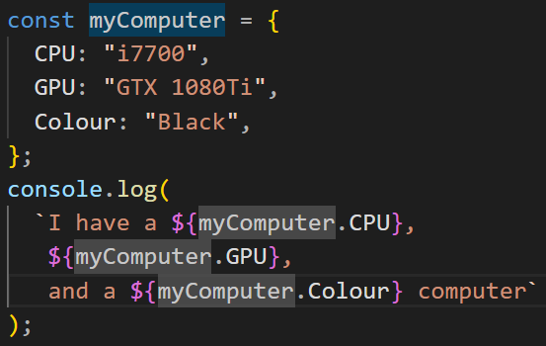

# Accessing object properties

* Property accessors provide access to an object’s properties by using the dot notation or the bracket notation.
* Specifically, values can ba accessed from objects in 2 ways:
  + Using the dot operator
  + Using the square brackets

# Dot Operator



The dot notation can be used to access the property of an object.

For example, to access the firstName property of the cat object, you use the following expression:



An expression is any valid set of literals, variables, operators, and expressions that evaluates to a single value. The value may be a number5, a string, or a logical value.

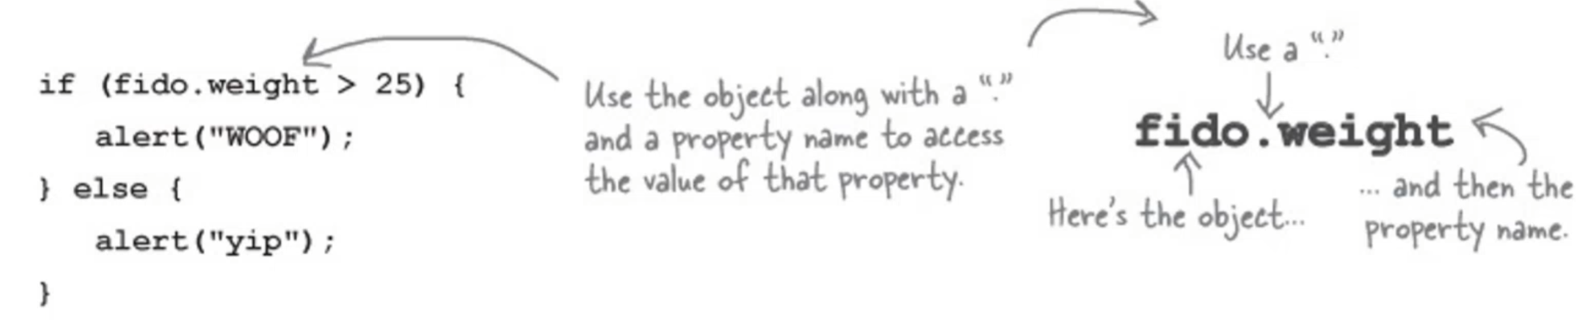

# Exercise 3

1. Add a favouriteColour property to your cat object
2. Log a string to the console: “This is firstName lastName, and their favourite colour is favourtieColour.” Use the dot operator.A picture containing text, font, screenshot, line

   Description automatically generated

# Square bracket notation – []

The square brackets property accessor has the following syntax.



To access the value of an object’s property via the array-like/square bracket notation, we use:



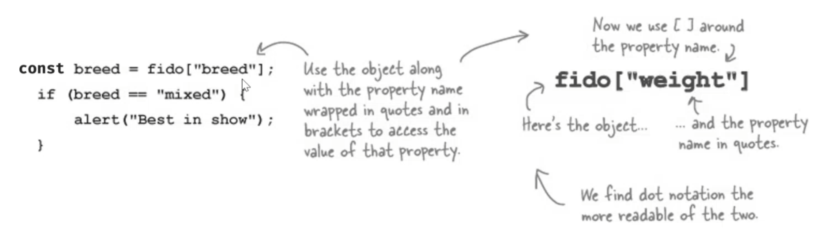

When a property name contains spaces, you need to place it inside quotes. For example, the following address object has the “street no” as a property:

The Property name could also be a variable that evaluates to a string denoting the property name.

# Exercise 4

1. Create an object called rectangle with 2 properties, length and width with number values of 10 and 50, respectively.
2. Log the area of the rectangle to the console
   1. The formula to finding the area of the rectangle:
   2. Area of a rectangle = Length x Width

Note: Access the object’s properties using the square bracket notation.

# Modifying the value of a property

Like normal variables, to change the value of a property, you use the assignment operator (=)

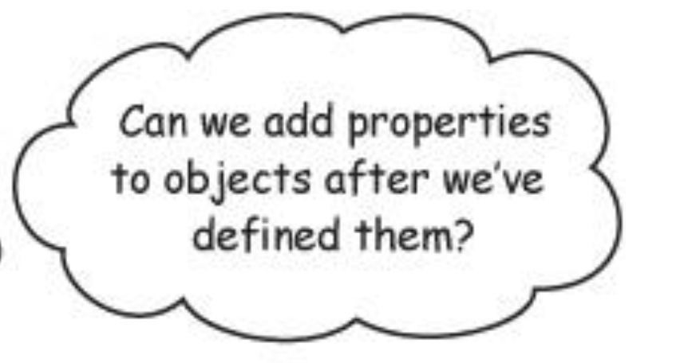

# Adding/Removing an object property

A JavaScript object is a collection of unordered properties.

Properties are the values associated with a JavaScript object.

You can add new properties to an existing object by simply giving it a value.



The delete keyword deletes a property from an object.

The delete keyword deletes both the value of the property and the property itself.



Exercise 5

1. Creates a newPerson object containing a firstName, lastName, favouriteNumber, favouriteDay properties.
2. Log the object to the console
3. Add a property called favouriteFood to the object.
4. Log the object to the console.
5. Remove the favouriteDay property from the object. Change the value of the favoutieNumber property by doubling the current number value.
6. Log the object to the console.

